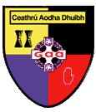
Carryduff GAC
AGM Agenda 2019

- Adoption of Standing Orders
- 2018 AGM Meeting Minutes
- Secretary Annual Report
- Annual Financial Statement & Accounts
- Chairman’s Address
- Election of Officers and Executive Committee Members
- Notices of Motion
- AOB

